Rapid Project Spec Using Object Technology

A Proposal for Advanced Application Development

by

Griff Jay

Smart Adaptive Framework

A set of applications which allows the analyst (note not programmer) to encapsulate objects, name them, record attributes about them, rank objects, categorize them, weight them, link objects, assign attributes to the links, and display and analyze the overall system of objects and links.

Contents:

I. Try This Challenge 3
Analysis 4

II. Rapid Project Spec 5
Rapid Project Spec Using Object Technology 5
From Imperfect Knowledge to Preliminary Plan 7
ProjSpec - Runs the Project, Expands the Business 7
ProjSpec - Payoffs 8
ProjSpec - Outputs 8
ProjSpec - Ongoing 9
ProjSpec - Focus 11
Appendix: ProjSpec by Phase 12

III. Smart Adaptive Framework 14
S / A / F 14
Technologies & Products 14
NoteObjects 16
Visualization Engine 17
Business Outputs 18

IV. Vision of a Productivity App 19
ProjSpec →→→ ProdApp 19
Mantra 19
The need is still apparent 20
What a product ought to do 20
Nature of apps / unique aspects 21
Criteria 23
Prototypes & demonstration apps 23
What business problem does it address? 26
What can happen to a feature over time 27
Incrementally more efficient 28
What the best developers are able to see 29
The apps jumble 30
Model repository using PA methods 31
Expansive global enterprise outlook 31
Thinking 31
Visionary 32
How expansive a claim? 32
The yeah-buts 32
Conclusion 33

V. ProjSpec One-Page 34
A Web-Based Productivity App 34

VI. Concise Presentation 36

I. Try This Challenge

TRY THIS CHALLENGE! (Please see the following page for a discussion of this problem.)

- There are five cars parked in a row.

- The German drives the red car.

- The French person likes chicken.

- Tennis is the favorite sport of the person driving the green car.

- The English person’s favorite sport is swimming.

- The green car is parked immediately to the right of the brown car.

- The mechanic likes pizza.

- The teacher drives the yellow car.

- Bowling is the favorite sport of the person who drives the middle car.

- The Italian drives the first car.

- The teacher’s car is parked next to the car of the person who likes pizza.

- The person who is the mechanic parks her car between the person who likes hamburgers and the person who likes chicken.

- The truck driver’s favorite sport is golfing.

- The Spaniard is the doctor.

- The Italian’s car is next to the blue car.

- The German likes potatoes.

Each person is of a different nationality and has one colored car, one different job, one different favorite sport, and one different favorite food.

Question: Which car is driven by the person who likes baseball?

Answer: ----------------------------------------------------------------

Question: Who likes beans as their favorite food?

Answer: -----------------------------------------------

Question: What nationality is the farmer?

Answer: -------------------------------------

Analysis
This logic puzzle is an example of a problem which may seem simple in construction but which is very difficult for most people to solve.

< 0.5% of people have sheer brain power sufficient to read through these 16 clues, keep the connections straight in their heads, think through the logic, and derive the answers.

Maybe another ~2% of people have the ability to use pencil and paper, jot down notes, draw a few lines, and use that as aid to thinking through the problem and deriving the answers.

Perhaps the next 5% - 8% of people have the ability to devise some kind of graphical representation with which to visualize the problem. It may be as simple as drawing blocks and connecting lines on paper.

For me personally, I needed computer aided design assistance. I used Visio, a graphical software package which provided two key capabilities which were necessary for me to solve the problem: 1) to be able to move the blocks around, and 2) to be able to connect blocks and then group connected blocks into single objects.

In this problem, we are given very definite information about some of the connections between some of the objects. The beauty of the object-oriented approach is this: once a clear connection had been made and the blocks have been grouped together, one no longer has to keep that relationship juggling in the brain. You can painlessly go on to making other connections between any two objects based on the clear information known about those objects.

Eventually various groups of objects coalesce into graphical patterns. It quickly becomes easier and easier to see which graphical objects could fit together and which ones could not possibly fit together. This presents a second key advantage here but which is a pretty subtle point: the average user can now empirically test the various pieces just by visually testing to see if it is possible for objects to fit together. At some point the problem will have been solved in this manner, and the user did not even have to pursue the logical connections all the way to their logical solution.

Now, I am an advanced Visio user, and I am also a software developer well-versed in object-oriented design and analysis. Could the average person without specialized knowledge or tools solve the problem as easily? I suspect not.

My children started bringing these problems home from school in the 6th grade. At that point they were being given 3x3 problems to solve. By freshman year in high school, they were bringing home 5x5 problems, such as the one presented above. I told them that it is very impressive that they can solve these problems. But then I said, “So what! I suspect that there are very few people in the whole world who could solve a 6x6 problem in their heads. And, so what! – an ecology model of wetlands is a million-x-million problem and an economics model of an economy is a kajillion-x-kajillion problem. No one is smart enough to solve those problems without having the right tools, an understanding of the right techniques, and a system which allows them to solve manageable components of the problem a bit at a time.”

I also pointed out one other thing to them. I said, “Remember how when you tried to solve this problem using method #1 (in your head) and method #2 (with pencil and paper scribbles) how frustrated you got, how tired your brain got, how hard you strained to juggle all that intertwined information? And then remember how effortless it was to just list exactly what we did know and to label blocks with that information and to connect the blocks. No problem at all, and the solution was reached, and we didn’t have to strain our brains to do it.”

If a problem is so hard that you get so balled up in it trying to hold onto all the details of the problem and you get mentally fatigued and you get frustrated, then that is a good signal that you are not using the right technique to solve the problem and you don’t have available to you the right set of tools needed to solve the problem efficiently, effectively, and pleasantly.

II. Rapid Project Spec

Rapid Project Spec Using Object Technology

A Proposal for Advanced Application Development

by

Griff Jay

You’ve been tasked to do a needs assessment for a complex system. It is multi-tiered, with multiple departments on each level and with multiple applications within each department. There is interaction and shared data between levels, between applications, between departments. There are summary requirements for the Executive level, more detailed info requirements for the Management level, specific instructions for operational support, and delicate issues and requirements for disbursing information to the public. A lot of solid information is known among the key players in various departments. Certain commitments are in place, time frames are in place, priorities are understood. However, there are huge gaps in what is known, more accurately huge holes of what is not known. You have to give a quick rough cut to both your CFO and the client CFO within days. In three weeks you have to deliver a project outline to the CFOs that contains a budget, schedule, and resource requirements.

Conundrum #1

An effective project team that could handle the assignment described above has to contain three sets of skills: 1) advanced technical talent, with experience at having done similar jobs, attuned to new technologies and development paradigms, 2) advanced applications expertise, knowing the science of the application and the jobs of the end users, and 3) advanced executive talent, who knows the business and financial model of the client and can interface with their decision-makers. In sum, three people each with about 20 years experience, a talent team that brings a combined 60 years experience to the problem. And quite frankly, a team that is exceedingly difficult to field. You can’t find them; you can’t afford them; if you could put together such a team, you can only send them to one locale at a time. What you can more reasonably expect to be able to pull together is a team of three bright young professionals, with solid credentials, good degrees, 5-8 years experience, and good heads on their shoulders, who can think. What you need for this team is a framework for collecting the information and the backup of those experts from the 60-year team, via long distance mentoring.

Conundrum #2

You are a small consulting firm with about $5M per year revenues generated by and supporting about 45 employees. The firm succeeds with perhaps 7 major client-directed projects, all fueled by the dedication of talented professionals, their stamina, and good intentions. What is the model that allows you to grow your company from $5M to $50M per year? That would require 42 such projects, with probably 240-260 employees. Now the situation is so complex that it is simply not humanly possible to manage it by stamina and good intentions. To make this order of magnitude leap, there must be a business and technical model in place that coordinates these activities, manages this complexity, and supports the business at every stage from executive to operations, from sales to bookkeeping, and most importantly from development to delivery to support.

Conundrum #3

How is the development team supposed to ramp up on the project if they haven’t been part of the spec team? How can they talk the same language as the client and the end user? and produce what the client was sold? How to avoid the disconnect and expense of re-ramping up?

Conundrum #4

How to track progress? How to spec the follow-up while the initial phase is still underway? How can accounting know when to bill for milestones? How can project information and intelligence keep being incorporated into the design and implementation without disrupting the flow and without the project calcifying around the original idea?

Conundrums #5, #6, #7, …, …

Scenarios Challenges Dilemmas Conundrums

I searched for an appropriate word for the business and technical problems cited above in the preface. The best one is not a word of every day use, and it is probably only known to English majors and columnist James Kilpatrick. But it describes the problems best:

Conundrum: 16th century Oxford University; early sp. quonnundrum 1) a problem for which there is no satisfactory solution, 2) any puzzling question or difficult problem, 3) a riddle whose answer contains a pun (Ex. “What’s the difference between a jeweler and a jailer?” “Once sells watches and the other watches cells.”)

Ok, forgetting definition #3 and leaving the jokes to a travelling juggling and vaudeville act, the first two definitions are what I was looking for. But are these business and technical problems really unsolvable? Are they like the cartographer’s map projection which at best introduces distortion and settles for compromise?

Since if I accepted definition #1, then there would not be any reason for this white paper, it is a good bet that I do think there’s a solution to these problems, and I endorse definition #2. That the problem is difficult should not be a deterrent – it just means that a new set of tools needs to be brought to the fray.

I propose that there is needed a new toolset, which I refer to as Rapid Project Spec, or ProjSpec for short. ProjSpec is a set of applications which allows the analyst (note not programmer) to encapsulate objects, name them, record attributes about them, rank objects, categorize them, weight them, link objects, assign attributes to the links, and display and analyze the overall system of objects and links. Rapid Project Spec is a system that assists you, guides you, allows you to quickly go from imperfect knowledge to a preliminary plan.

Rapid Project Spec

Please re-read Conundrum #1 above. I was part of the team that was tasked to spec that multi-dimensional problem. We were good, and we were dedicated, and we produced a good needs assessment and a good preliminary plan. But what we realized was that we were relegated to trying to model a complex, multi-dimensional problem with a set of flat, two-dimensional tools, i.e. Word tables, Excel spreadsheets, Visio drawings, MS Project timelines, etc. Those are all paper-based, flat, conventional, two-dimensional tools, and no matter what kind of innovative ways we tried to interrelate them, they were not adequate to perform the multi-dimensional analysis we needed.

Thus I was set along a process of trying to articulate what is the nature of the problem and to devise what would be an effective solution.

From Imperfect Knowledge to Preliminary Plan

When you go into a situation as a consultant, you do not have to be omniscient to nevertheless quickly amass a lot of real, verifiable, and useful information. The clerks, specialists, and managers on the client site do know their jobs and how their business runs. So the consultant can quickly amass a great deal of information about their activities, about priorities, about deliverables and dates to which they are committed. One can catalog the data layers in use and their flow between functions. One can rank activities by percent likelihood, by potential revenue, by chance of failure, by return on investment, and by other useful measures.

Now, obviously, information gathered so quickly cannot be complete. And all that is left in between - what is unknown to you - is so vast that holes seem to gape large enough for the proverbial truck to drive through. Should that circumstance keep you from acting? Should it freeze you in place? No - business realities won't let you - remember that the clock is now ticking, and you are committed to delivering a preliminary budget, schedule, and resource plan in a matter of days to both yours and the client's executive management.

Conventional top-down or bottom-up design assumes that, with time and research, you will be able to fill in these gaps and present a complete scope of the project. And then from that point, there exist tools, tables, spreadsheets, charts, trees, etc. for labeling tasks, relating them, scheduling them, etc. HA!! The market compresses the time to the minimum, the complexity of interrelations quickly exceeds these tools' ability to convey them, and the frenetic pace of changes in technology surrounding the project defeat such a design almost before it is completed. Once again - should that immobilize us? No, no, friend (once again - remember, if I thought there was reason to be immobilized, there would be no reason for this white paper), that should just inspire us to look for some different tools to augment the process.

Notice that I did not just then say anything to the effect of replacing old tools with a new set of tools. That's an important point to keep in mind throughout. Tables, spreadsheets, charts, and diagrams are how business does business. And we want this information which we amass with new tools to be used by the decision makers and business leaders. Moreover, we want it to be integrated into the operations of the business, and to serve the functions of monitoring, managing, and planning the business.

No, what's needed here is the ability to quickly capture, interrelate, and convey all that we do know. We need to be able to encapsulate lists and weights and measures of likelihood, etc. as data objects; we need to label them with terms that are commonly used by the client business; we need to attach attributes to the data objects in some free form manner as they occur to us; and we need to make the connections between objects that are evident at the time. In fact, the connections themselves must be considered objects, also with attributes.

ProjSpec - Runs the Project, Expands the Business

Now I realize that we haven't yet generated the preliminary plan promised above. However, at the risk of delivering more of the best punch lines early in this discussion…

…I think that ProjSpec serves not only the preliminary spec'ing of the project, but it also provides the way to run the project, and the way to run multiple phases which may overlap, and the way to run multiple projects concurrently, and the way to expand and manage the business of running all those projects.

To do that, ProjSpec must be a tool <a set of tools><a process><a consistent approach> which can be applied during each project phase: 1) Needs Assessment, 2) Specification, 3) Prototyping, 4) Implementation, and 5) Review & Redesign.

At the end of this document is an appendix which details how ProjSpec impacts each of these phases. For now, let's just abbreviate into a catchy slogan for each phase:
- Needs Assessment - "best guess with the information available at the time"
- Specification - "more complete information"
- Prototyping - "validate assumptions and build framework"
- Implementation - "progress reporting"
- Review & Redesign - "project revision, enhancement, and expansion"

ProjSpec - Payoffs

ProjSpec plays and pays at the Project level, at the Management level, and at the Executive level.

At the Project level, the developers face an absolute jumble of minutia, all of which must be taken into account, interrelated, rationalized, and programmed. If one does not encapsulate all this information and functionality into objects and use them to create components, then the development is doomed to remain haphazard and amateur. Professional programmers have long since adopted the object model to organize and manage this complexity, and there are toolsets and an industry sector focused on programming modeling.

A perceptive reader might say at this point, "Why then can't we just use those software modeling tools for the ProjSpec concept?" One answer is that the output of those products is software code and reports about software code. The output from ProjSpec must be management information and executive information.

Management level must be able to count on two things: 1) that this modeling of the jumble into object components will result in productivity improvements and 2) they must see that the productivity improvements make it possible to manage orders of magnitude increases in complexity and in speed of change.

The Executive level must see that the implementation of ProjSpec will translate into increased profits and present the opportunity for conquering markets - not just compete, but conquer and dominate market segments.

ProjSpec - Outputs

For the object modeling component level, ProjSpec should have 3-dimensional display capability. The viewer needs to be able to view the relative size, shape, and position of objects and the nature of the links between objects. Size, shape, and position are reflections of selected object attributes, such as - measures of complexity, percent completion, resource requirements by the object, cost, etc.

Recall that I've repeatedly called this a multi-dimensional problem. However, since humans see and think in just three dimensions, the ProjSpec display must let the user select different viewpoints from which to view the project. This is analogous to digital terrain display software which allows the user to pick a geographic viewpoint and an azimuth and then shows what is visible from there. It also allows for a walk-through or fly-through over the terrain - in this case, through the model.

At the Development level, the details of the components and their object attributes serve both to direct the activities of the development team and then to re-absorb the results of the development activity. Thus the "spec", which was captured in the object early on, specifies for the developers what needs to be done. Then when development on this object has been performed, the actual shape of the object (which invariably evolves and changes from the original spec) redefines the object. The object notifies the rest of the system of its status and its capabilities and availability for use elsewhere in the system.

Although Management level is also human, ProjSpec output to them is two-dimensional, not three. The language of business is budgets and tallies and schedules, and the media for those are spreadsheets and tables and calendars. So ProjSpec must be completely grounded in the office environment and talk fluently in the language of the office tools. In the current business computing environment, you may just as well capitalize Office (as in MS Office), and you must make sure that ProjSpec writes Word reports, Excel spreadsheets, Visio drawings, and Project timelines, because those are the formats that management can process, refine, and incorporate into their own activities and reports. And it can't just be import and export from Office like almost all products try to do, because those filters are invariably lame, time consuming, and proliferate copies of files and information. No - ProjSpec objects must report themselves for processing in native format by the tools themselves. How else would we expect ProjSpec to become useful in every office in every industry?

So as described so far, ProjSpec can expand out to the detail and minutia that allows the developers to do their job (3-D & multiple-D) and also compresses down to summaries and reports for management (2-D) to do its job. To the Executive level, ProjSpec delivers even more succinct summaries, i.e. lists of bullet items (1-D), because that is all the face time your project is going to get to compete for attention and get the green light from people assailed with requests and without the time to wade through the clutter of project details.

Somewhere between the 2-D and 1-D, ProjSpec will have delivered the preliminary plan promised early in this paper. And as soon as the green light is received, ProjSpec immediately turns back around and instructs the operational teams with how to proceed on management's directive and the spec team's information.

ProjSpec - Ongoing

The project has been launched. The spec team is out specifying a new project. Implementation of this project is underway. Is the name "ProjSpec" now a misnomer for all the functions I envision it continues to serve in managing, completing, delivering, and billing the project?

Implementers learn as they develop. A system that allows them to evolve the design of the project is essential, otherwise the design calcifies at the point where management approval was granted. What is learned by the developers is encapsulated in the objects, and knowledge about the availability of completed objects and components must be fed to all the functions of the business. This information is needed by the project spec teams to use on subsequent jobs, by Sales to use to cost proposals, and by staff to be able to respond to RFPs. The results from multiple projects define a baseline of information about how this business performs, and with that comes the ability to estimate dollar values which are no longer out-of-thin-air guesses.

For ProjSpec to produce this stream of development information, it has to be embraced by all developers across numerous projects. This may be the point at which cynics say, "Oh, those ornery, independent-minded developers, they'll resist and defeat all attempts at enforcing a model on them." On the contrary, good developers embrace a ProjSpec-like system, because it works like they work. It allows them to proceed with development on things that they are proficient in doing, and it allows them to come back and fill in gaps as more is learned. It allows you to capture innovative thoughts at the moment they occur to you, and later it categorizes these things as they take on attributes and shape, and it becomes apparent to which class they belong. Since the object model of ProjSpec allows for inheritance of attributes for like objects and for derivative objects, developers don't have to revisit and reinvent. A sufficient accumulation of development efficiencies produces orders of magnitude in increased productivity, which translates to the business as competitive advantage. I know of no professional developer who doesn't wish to participate in precisely that favorable position.

Most small company development environments involve a few key developers who embody all the knowledge of how their system was put together and how it works. Demands on the key developers are constant and always increasing. To expect them to get everything working and to also document the system is not usually realistic. They don't have the time to retrace their steps and enter information about what has been done. A ProjSpec-like system captures what they are doing as they do it, and its reports become automated means for producing documentation and responding to other administrative requests. ProjSpec has an intuitive, self-reinforcing role, and as such is a good friend to the developers, embraced because it unburdens them from administrative duties.

When the business succeeds, those few key developers invariably become key support resources. They know everything, and if no system has been put into place to capture that information, then they are by necessity invariably drafted into assisting user-support. Ironically, for what probably is viewed by other parts of the business as a simple request for support, that very act of responding to it takes the best developers away from and diminishes their ability to develop.

From the administrative, management, and executive viewpoint, one of the simplest of requests to developers is for periodic status reports. They may be surprised to know that for the developers it is a particularly onerous and unproductive task, because it disrupts their development process, asking them to re-create what has already been accomplished and which they have already moved past. One can either talk about programming, or you can actually program. When the development is at its most creative and most productive is not the time to interrupt for weekly or monthly reports. With the self-documenting and self-reporting nature of ProjSpec objects, they know when they are created and when they are done and who is working on them and what shape they are in and what their capabilities are and where they will interface and so on and so forth. When ProjSpec extracts this information directly for the administrative, management, and executive groups, they get timely, unvarnished status, while leaving their best developers unburdened.

In my experience with small companies, they are notorious for working for future considerations and failing to realize current revenues. Quite bluntly, they too often leave money on the table. Work may have been performed, but Accounting is still waiting for a developer to remember to notify them that it is ok to invoice. Better that project milestones be self-reporting - the system in effect notifying Accounting as soon as any milestone has been completed, thus triggering timely invoicing.

Remember that costly team we put together early in this paper? The one you can't afford to dispatch? With Web-based long distance collaboration and mentoring, they can now be available to all of the spec efforts. So now multiple teams can be dispatched, all with access to the experts. In the field, those teams can expect ProjSpec objects themselves to answer many questions, plus they always know that the senior experts are available for augmenting their capabilities. In a similar vein, these objects become the heart of the company's support capabilities, and via web-based collaboration, the support function can also access the senior talents when it is especially needed and appropriate.

ProjSpec - Focus

Dustin Hoffman in The Graduate is told, "Plastics" - key to the future. The key to ProjSpec may well be "XML".

When we left the project in Indonesia in October of 1997, the concept of ProjSpec was fairly clear to us, and we understood that it needed to be built on an object model. However, I was troubled by knowing that OO databases would never become mainstream in business and offices, where ProjSpec ultimately has to reside. I also didn't have a good answer for my colleagues' questions about how the so-called junior teams would be able to access ProjSpec software.

In the intervening couple of years, the Web has answered these two questions. XML provides the means to encapsulate data and quickly label it using terms attuned to the client's own business terms. XML-specified data can then be processed and presented in different ways by different office applications. And now, the new generation of database servers understands XML and can input and output data in Web-ready XML format.

Another Web advancement which is favorable for ProjSpec has been the advent of Application Servers. This is the means by which a team in the field can access the corporate database, how multiple projects can call on and contribute to the same database, and how teams in any time zone can have 24/7 availability to these capabilities.

ProjSpec teams can now perform around the world, with access to the application server back at the corporate Web farm. Less experienced teams can be dispatched because they know they have a framework within which to collect information, a system of objects they can mine for the components they recognize are needed by their client's projects, and access to the experts and support they need to confidently master the complexity of the situation they face.

ProjSpec addresses the conundrum of rapid project specification. It turns out that definition #2 was the correct one - the complexity we face does present us with challenging problems, but they are neither impossible (definition #1) nor a joke (#3). ProjSpec is the tool for specifying jobs, for implementing projects, and for expanding the number of projects that can be managed simultaneously. ProjSpec is for developers and managers, for admin and executive. ProjSpec is doable.

Appendix: ProjSpec by Phase

I. Needs Assessment
"best guess with the information available at the time"
List client requirements
Be able to categorize functions, applications, tasks, etc.
Rank and weight items by priority, by complexity, by logical order, by operational due dates, etc.
Be able to define broad classes and general definition of objects (functions, apps, tasks, datasets, data layers, etc.
Produce preliminary report - summary of above items
Estimate costs, schedule, & resource requirements

Result: Quickly deliver a report with ballpark time & dollar figures which the client's management can accept and approve and which we can confidently know will suffice to complete the project and at a profit.

II. Specification
"more complete information"
Extrapolate from well-specified functions, apps, & tasks to other categories
Complete the specification for other categories
Recalculate the dollar & time figures with more complete & precise input

Result: Fills out the picture and contributes more detail to the cost and time figures. Can go back to management with "best and final" quote. If phase 1 is on target, these numbers buttress the original decision(s). If numbers here significantly differ from phase 1, then maturing of ProjSpec objects and process will provide means to better estimate future phase 1 exercises.

III. Prototyping
"validate assumptions and build framework"
New tasks identified as development work commences
Revision of requirements as project discussions continue
Template work performed here is basis of multiple objects across different categories
Task breakout for final specification of development to be performed in the implementation stage by staff
Feedback revises Specification stage

Result: Validates the technical assumptions underlying the project - builds a development framework for project implementation.
Result: Ability to roll up all project documents into generalized management summary and roll down all project documents to minute project detail.

IV. Implementation
"progress reporting"
Methods to track progress, measure milestones, invoice by task number
Refinement of all objects with what is learned during development
Feedback to overall project model if any major obstacles are encountered or slippages occur

Result: Automate status reporting and budget tracking

V. Review & Redesign - "project revision, enhancement, and expansion"
Re-evaluate user requirements
Design next generation of applications
Measure the impact which feature requests and "what if" requirements will have on the project

Result: Ability to revise and enhance the first generation of applications while at the same time expanding the project to new functional and application areas.
Result: Job costing based on a tested object model which has been tailored to this project.
Copyright 2000. Joseph G. Jay. All right reserved.

III. Smart Adaptive Framework

S / A / F

The whitepaper in which I outlined the initial conception of ProjSpec was largely written in 1998, then revised in 2000. Now, to me, it has the feel of being dated. Yes, it accurately anticipated the importance of XML and of Web apps, but it necessarily had to await the emergence of some new technologies and improvement in my understanding of others.

Technologies have emerged (or just have become apparent to me) which begin to complete the description of what we have come to call S/A/F (Smart Adaptive Framework). It is a less geeky name and one more descriptive of its intent.

Technologies & Products
Technologies to Integrate into S/A/F | XML  Search Engines  Clustering  Visualization  Decision Engines  XTM (XML Topic Maps)  FCM (Fuzzy Cognitive Maps)  High-End Graphics  Surface Modeling & Display  Subsurface Visuals  Business-Grounded Applications
Distributable Products from S/A/F | NoteObjects  S/A/F Visualization  Business Outputs to All Business Functions  Analysis and Decisions  Project Management
What Sells S/A/F? | Light-on-its-feet application(s)  Framework for project success  Supportive environment ‘guiding’ the ‘next 25%’  Handle multiple projects  Handle multiple phases in each project  Handle order of magnitude in complexity  Handle order of magnitude in speed of change

The need for such a product still is apparent. In the intervening years, every time I have talked with an executive, a manager, or a project director, I have asked this question: “What framework or environment do you use to manage your project(s)? What app is there for coordinating the details, for directing the production, for producing management information, and for providing executive summaries?” Now granted, those individuals don’t constitute a statistically valid sample. Nevertheless, not one has had much of an answer – not one! They all agreed that they could use such a product, and they admitted that their projects were still generally run on (in my words) “stamina & good intentions”.

The following diagram lays out both the technologies needed to develop an S/A/F and the products which it would produce. It speculates on the time frame in which the technologies and products would be expected to mature (green = currently available, blue = in the midterm, and red = in the long term).

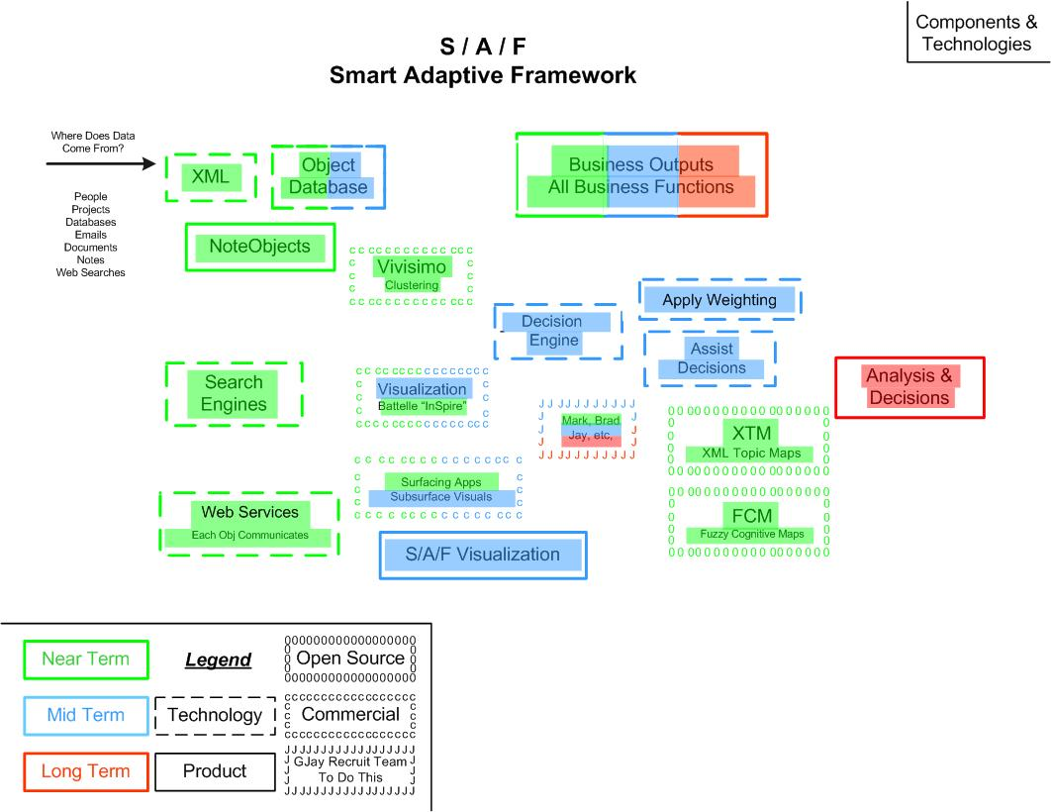

XML still remains at the heart of what I call the object database. Capturing everything as XML objects is simple and fast, and it can now rely on the underlying database to store and retrieve them magically sight unseen.

Every piece of information (textual, numeric, and graphical) is captured as an object. Objects coalesce into larger objects, and larger objects form into classes of objects. Attributes can be tossed onto an object (in a free form manner) and be expected to stick. Designers and users of the system do not need to have any a priori knowledge of what attributes will be appropriate for each object.

Search engines and clustering do the retrieval and categorizing of objects. These technologies are mature now, produce accurate results in real time, and will only get better with each passing year. With these engines integrated into S/A/F, end-users will view the clusters of objects based on any combination of attributes. This leads to the description of the first product:

NoteObjects

NoteObjects, in its simplest form, provides a clustered tree-view of related information items, i.e. clustered XMLs. A requirement for the NoteObjects app is that it has to be as easy to use as Notepad (or perhaps Excel – the fact is that MS Project is too complex and has too much baggage to be used by the average office worker).

For NoteObjects, picture a version of Notepad in which every time you enter Carriage Return <CR> at the end of a line, that line of text is captured as an XML object. Then with a fast clustering engine as the basis, users can view clusters of information via a tree control.

Example: as a manager, information pops into my head constantly, all day long, which I must remember to convey to my staff members. Rather than a paper note, rather than an email, rather than a verbal instruction, rather than a voicemail, rather than waiting for a meeting, it is much, much easier to just type in the random thoughts. NoteObjects would, behind the scenes, immediately capture the notes as XML objects, and the objects clustered together in any of several ways, based on the contents of each note.

When I come into work in the morning, I’d use NoteObjects to display all notes which contain my name in order to see who may be asking me to do something or what information someone may be asking of me. Then I might display all the notes with are related to one particular project in order to see what kind of activities have been taking place on that project. I might display all items which have the words “done”, “finished”, or “completed”. (Note: those would be clustered and presented to me, not a keyword search by me nor having to know how to invoke some stored SQL.) I might display on percent done. I might display on any of dozens and dozens of attributes. The significant point is that no one had to a priori define what these attributes are. Search engines and spell checkers now search on “sounds like”, “near miss”, “means a similar thing”, etc. Thus users are allowed to throw attributes into the mix in the manner that their business labels things. A similar significant point is that the attributes are in the terminology of the company’s culture and business model, not in computer-geek-speak which historically database applications have imposed on the users.

Visualization Engine
There has to be an intuitive way to graphically see the objects in relation to each other and to have the objects colored based on the type of attribute and it current values. There has to be an intuitive way to watch the objects grow or wane (become more important or less important), glow or dim (based on the magnitude of attribute values), change shape (as the information about the object is relatively complete, relatively incomplete, or skewed in one direction or the other).

The graphics must be 3-dimensional. It is actually a multi-dimensional problem, but we humans see things in three dimensions. So there has to be a way to “walk through the model”, i.e. see different dimensions from different angles, to look downward to get a high-level macro view of the project, to take a ground level view of the relative position of objects around you and look up from beneath to get an under-surface view of the model infrastructure.

The connections between objects are extremely important, as significant as the objects themselves. Each connection between any two objects must have attributes of its own, i.e. the direction of the connection, whether it is bi-directional, strength or tenuousness of the connection, time and expense related to the flow of information between objects. The line style (solid, dashed, dotted, etc.) and thickness of the line are determined by the strength and nature of the connection.

The product is a tool for visualizing the essence of complex projects, a model that “forms itself up”. To use it would be intuitive and easy, with a mode for “walking through” the model. The reality is that every project becomes exceedingly complex even within hours, certainly within a few days – such a capability would be invaluable.

That complexity inevitably surpasses the ability of individuals to keep track of all the details and follow the intricate web of connections. Therefore flexible visualization apps are needed to expand this capability for the user. Two technologies exist to assist in this effort – integrated with the graphics they become analysis tools, i.e. products of S/A/F – XTM and FCM – XML Topic Maps and Fuzzy Cognitive Maps. Integrated with routing algorithms, they’ll show logical paths through the connections, giving the user the ability to see the connections that have been made, or should be made, are significant, or are insignificant, are taking on more significance all the time, or are diminishing in importance.

A “philosophy” of S/A/F could be that every object be considered in its own right as a self-contained service. In this concept, every object “announces” to the overall system: “here I am”, “this is what I do”, “this is what I need”, “who wants what I offer?”, “who has what I need?” Objects “negotiate” with each other, “interact” with each other, form connections with each other, etc. In this manner objects grow or wane as do organisms in other complex systems. When a significant thing happens to an object or when a significant connection is made, then the system sends messages and flashes signals, so users’ attention is drawn to the area where they should be paying attention.

Business Outputs
This is the central product delivered by S/A/F – business outputs to every business function across the enterprise. We are in the business of process modeling, project modeling, decision modeling, business modeling, and the output from the system must focus on business products – summaries, totals, status, budgets, time lines, resource requirements, progress, logjams, revenue tracking, notification of what is working, notification of what is missing – the business products needed by business decision makers to keep their projects on track and get their products to market ahead of their competitors.

The system has to start producing those products from the outset. Note the green, blue, red shading in the diagram – useful products from the inception, expanded projects in the mid-term, advanced products in the long term.

The framework, just by collecting, clustering, and classifying information, is enough to take most employees and their projects over-the-top – increasing success, productivity, profits. In and of itself, that is sufficient to justify development, distribution, and adoption by the market.

The exponential payback is when decision engines go beyond just organizing data and effective visualization. When decision engines undergird growing, evolving, adaptive models is when project members can expect to be pointed to critical points and emerging problems (in a relatively unstable, still emerging model) and to efficiencies and high payoff points (in a mature, relatively stable, but always evolving model).

What will fuel this decision engine? Fuzzy logic? Bayesian logic? Neural processing? I expect a hybrid of these, combined with other advances with which at this point I may not be aware. This is not an area in which I profess expertise, but what is certain is that just over the horizon there is going to be sufficient processing power to handle it.

How expansive should a claim of market potential be for this product? With a product as easy to use as Notepad, visualization that is intuitive for everyone to see and use, business outputs and guidance for every business unit in the enterprise, tight integration with MS Office suite, models built on robust, adaptive, believable decision engines, all in the terminology homegrown in each business … there is no reason not to believe that the potential is for it to be used in every office in every business worldwide, all of which can benefit from:

- Efficiencies in individual projects
- Multiple projects simultaneously
- Multiple phases in each project
- Manage orders of magnitude increases in complexity and in speed of change
- Garner information from everywhere – intranet and internet
- Mine the marketplace of ideas
- Build – grow – adapt – thrive

IV. Vision of a Productivity App

ProjSpec →→→ ProdApp

The two white papers have laid out the concept for Rapid Project Spec in a Smart Adaptive Framework. In discussions of ProjSpec–S/A/F with colleagues and interested parties, they inevitably ask me exactly how such an app would look, but especially how it would be developed.

I tell them – without unwarranted modesty – that smarter and more capable people than me would be needed to answer that. I can’t tell them precisely how to get there, however I can describe what the nature of the app should be – not too strong to say, what the nature of the app must be – in order for it to be readily accepted and widely used.

The productivity app needs:
- the data gathering and retrieval power of Google,
- the collaborative environment of Groove,
- the graphical displays of Starlight,
- the fuzzy logic brain of Massive [Lord Of The Rings digital modeler],
- the ease of use of Napster,
- the widespread and intuitive use of eBay, PayPal, or Map Quest, and
- the real-time interaction of multi-user web games.

Mantra
Ok, I tell colleagues, if we’re not exactly sure how all those pieces will be put together, we can settle on some fundamental characteristics. Every morning, the development team should repeat this mantra:
– Simple – Fast On Its Feet – Self-Reinforcing – 2007/2010 App
– Simple – Fast On Its Feet – Self-Reinforcing – 2007/2010 App
– Simple – Fast On Its Feet – Self-Reinforcing – 2007/2010 App
– Simple – Fast On Its Feet – Self-Reinforcing – 2007/2010 App

– Simple: – no harder to use than Excel
– all the better if as easy to use as NotePad

– Fast On Its Feet: – adapts to constantly changing environment
– adapts to constantly changing requirements

– Self-Reinforcing: – users use it as a matter of course in doing their jobs
– no backtracking to record info

– 2007/2010 App: – can take advantage of the coming explosion of computing power
– can thrive through multiple versions

The need is still apparent
I asked a colleague, “How are most projects managed?”

He responded, “Well…financial tools to monitor the budget…work breakdown structure, GANT charts, databases to plan and to track progress…manual filing, note taking, progress reports to coordinate activities and inform managers.”

“So,” I continued, “what’s the reality of the projects you have observed?

His response, “Well…generally hit or miss…rely on heroic efforts…run on politics rather than metrics.”

Then I asked, “What characteristics would you expect to see in a good project?”

His response, “Framework…process…intuitive methods…metrics.”

With those in place, developers receive direction, management stays informed, and product gets delivered. Simple – Fast On Its Feet – Self-Reinforcing – 2007/2010 App.

What a product ought to do
Ok, let’s trot out some clichés here. Even so, this is what the app should do:

- It should deliver solutions. Developers…keep in mind that you are not just developing software, you are not developing systems…you are developing the means for users to devise solutions.

- Be object-oriented not only in its internal design, but object-oriented in its use. By that is meant that each attribute of each entity is scored based on two factors – the value itself and the confidence level in the value.

- Use intuitive graphics in every step, so users get constant visual feedback about all inputs, actions, decisions, and solutions.

- Have a simple, simple, simple user interface. Great complexity will reside in the engines, but always and only simplicity facing the user. Decision support systems have great promise, but technological solutions generally run the risk of becoming too complex for the very people they are intended to help.

- “Orchestrate dispersed domain experts” [Groove.net]. Even if project teams are not separated by geography, which normally they will be, they are always dispersed through time. People come and go constantly, people travel, people have families, people contribute to projects in fits and spurts. Rather than try to choreograph their activities via meetings and set schedules, embrace this constant movement and sporadic contributions, and integrate it all into an organic whole – a framework for processes and methods which coalesce into results.

- “Process that leverages the domain expertise” [Ammon Cookson, Lean360˚] Let the domain experts operate using the terminology of their domain – do not expect them to adapt to the terminology of computer speak, of network speak, of system speak. Let businesses perform all steps in the terminology of their industry, and the app will readily gain acceptance.

- “Flexibility and expressive power” [Carl Niedner, Coelo Company] Put that in the hands of end-users, and let them go about their business. End-users are tired of having to try to teach their disciplines to programmers, so that they can eventually receive a lame app, which almost but not really addresses their business problems. Of course, those problems are changed rapidly by market forces long before programmers can deliver results. Programmers should disabuse themselves of the idea that they can ever keep abreast of the details of the business – what they must focus on is building a framework with flexibility and expressive power, and then step back and allow end-users to do business.

- “From data intelligence to actionable items” [A. Cookson] Give the ways for end-users to transmit results, to display progress, to interact with clients, to report to management, to be able to see through the data to discern effective actions they should take…all the while confident that the process has been self-documenting.

- “External integrity” [Mary Poppendieck, Lean Software Development] Whatever tool the end-user faces, he/she should intuitively understand how to use it and countenance a consistent “feel” about the tools. Note – that is not expressed as “look and feel”, because this concept does not imply that all tools have only one appearance, rather, when migrating from one tool to another, it is obvious to an end-user how to proceed next.

- Gestalt (n.) : a configuration or pattern of elements so unified as a whole that it cannot be described merely as a sum of its parts [Webster’s Dictionary]. Flexibility and expressive power which produces actionable items – users will revel in the gestalt, without having to know what that means.

Nature of apps / unique aspects
A colleague of mine has developed a ground-breaking database technology, around which he and his partner have built their consulting practice. There are two fundamental, overriding, significant advantages of their methodology:

- Neither the developers nor the end-users have to be omniscient before starting a project. Apps and data can grow organically as situations are encountered and more is learned.

- All metadata / all the time – meaning that the who/what/where of all transactions is recorded and available for reporting or further processing.

In project parlance, what does it mean to say that you don’t have to be omniscient?

- Other database applications require that you pre-define all columns, fields, permissible content values, index fields, etc.

- But my colleague’s concept acknowledges explicitly that, in complex applications:

- the client (not only most of the time, but always) can not anticipate all the requirements which will be needed,

- the programmers cannot anticipate all the technical issues which will be faced,

- applications face rapid technology changes,

- applications face rapid market changes.

- Since everything does not have to be preplanned, their applications are:

- adaptable,

- flexible,

- fast on their feet.

What does it mean to say that their tools and apps are predicated on metadata?

- metadata is viewed as just data,

- thus operations on metadata are as fast and efficient as operations on data,

- objects have their own metadata,

- collections of objects have metadata describing the relationship between and among the objects,

- collections of collections have metadata describing the relationship between and among the collections,

- fast, smart logical operations can be performed on metadata,

- the intelligence of retrievals expands as additional metadata accumulates.

Criteria
Continuing the dialog with the first colleague, we set out to list what would constitute the productivity app. If it could do these things, then it would be an app that we would want to use on our projects. It would do (or would have):
  - Accumulate
- Share
- Display
- Interact
- Smarts
- Intuitive Actions
- Intuitive Results

So, where would one find such capabilities?
- Accumulate………….data gathering and retrieval power of Google
- Share………………...collaborative environment of Groove
- Display………………graphical displays of Starlight
- Interact………………real-time interaction of multi-user web games
- Smarts……………….fuzzy logic brain of Massive [Lord Of The Rings digital modeler]
- Intuitive Actions…….ease of use of Napster
- Intuitive Results……..widespread use of eBay, PayPal, Map Quest

Prototypes & demonstration apps
Could we spec prototypes and demonstration apps which would showcase these capabilities? We defined seven demos for the PA (i.e. productivity app):
- Logic Induction Demo (accumulate, display, smarts, intuitive actions)
- Demographics Demo (smarts, intuitive results)
- Messages Demo (accumulate, share, display, interact)
- Multiple Apps Demo (accumulate, display, smarts, intuitive actions)
- Pipeline Demo (non-omniscient, interact, smarts)
- Business Process Demo (accumulate, display, interact)
- Hand-Held, Wireless, Computing Power Demo (accumulate, share, interact)

Discussion of the demos:

- Logic Induction Demo
Intent: Solve a 5x5x5 logic problem graphically. There are five individuals, each with a separate nationality, each with a different color car, each with a different favorite food, each with a different favorite sport, and each with a different profession. You are given 16 clues about who likes what, who does what, and who drives what. From that, we are left to figure out:
- Which car is driven by the person who likes baseball?
- Who likes beans as their favorite food?
- What nationality is the farmer?
The intent is to demonstrate that the PA can easily import the data, record all the attributes and connections between entities, and answer the questions correctly.

- Demographics Demo
Intent: Take age, weight, and height data for “nnn” different people through their life span. Each person is an entity; for each attribute, there is a value [years, lbs, inches]. Using the PA:
- Find the Tall, Skinny guy. (e.g. 6' 5" & 129 lbs)
- Find the Short, Fat guy. (e.g. 5' 3" & 180 lbs)
- Find the kid who is Big For his Age. (e.g. age 10, 5' 11' & 175 lbs)
- Find the adult who is Small For his Age. (e.g. age 29, 5' 1" & 115 lbs)
- Find the young adult who had delayed development. (e.g. normal size through Adolescent, then no growth through Teen & College, a growth spurt as Young Adult, then normal size as Adult).
The intent of this demo is to use very intuitive data and then ask difficult questions, which require more than just querying the data, they require interpretation of the relationships between data.

- Messages Demo
Intent: – Take simple declarative instructions and messages.
– Capture them as entities.
– Associate the entities with each other (i.e. establish the intuitive connections which are implied in the messages).
– Retrieve the messages based on any combination of attributes.
This is a demo of an electronic journal application. It demonstrates the ability of the PA to store and retrieve information intelligently. It demonstrates PA’s capability to handle new attributes as they are encountered (i.e. no one had to be omniscient and pre-define what PA would recognize and act on).

- Multiple Apps Demo
Intent: Rapidly spec a multi-level, multi-app software system. In an extremely short time frame, come back with a preliminary report, which must provide ballpark estimates for the time, budget, and resource requirements to develop the system. Obviously there is not time for in-depth research and specification of every function and application. Must estimates just be wild guesses? Or is there a way to start with known information and high confidence estimates for a few entities, and from there derive figures which will stand up to the test of time and more complete information?
The intent is to demonstrate how the PA will process objects with attributes and to:
- let attributes accumulate as real verifiable information is collected,
- allow newly encountered attributes to be defined in the local terms used by each department,
- demonstrate that no one could have been omniscient and known what kinds of information would be encountered and what requirements to anticipate,
- use “fuzzy” comparisons to extrapolate from high confidence information to reliable estimates for less clear requirements,
- derive ballpark figures for budget, time frame, and resource requirements which are defensible,
- demonstrate the PA’s ability to ingest data, create entities, attach attributes to entities, infer logical connections between entities, and be able to highlight, sum, and report data based on different combinations of attributes,
- demonstrate the PA’s ability to accumulate metadata about entities and collections of entities, so that the retrievals and type of questions which can be answered get smarter and smarter as more and more information is accumulated.

- Pipeline Demo
Intent: Translate the PA’s capabilities into domain specific terms.
- Present examples to industry executives in the terminology of their own industry. That way the demonstrations will resonate with them.
- Demonstrate the PA’s ability to create a network (web) of entities and to attach attributes as they are encountered.
- Show that by induction, changes somewhere in the network can be interpreted as having effects elsewhere in the network.
- Demonstrate an example of when, after a long time period, new unanticipated attributes are encountered for a few entities and therefore are introduced into the system.
- Measure and report the effects of those new attributes on the overall system.

- Business Process Demo
Intent: Produce a set of general business application demos. Recall that our intent is to cast demos in industry-specific terms so that they will resonate with domain experts and businessmen in that industry. Think in terms of trigger events that would send a business organization into response mode and which would require the interaction among numerous departments, such as:
- some kind of catastrophe happens,
- a contract award is received,
- a new hire,
- an outsourcing decision,
- change in suppliers,
- an employee strike.
The premise is not that someone would pre-devise an intricate business process model trying to connect all possible interactions between corporate departments and individual entities. The premise is based on the PA’s acceptance of the reality that you don’t know up front which attributes each entity will ultimately attach. And…whenever the PA encounters a new attribute for an entity, it can add it at that time, and just because one entity picks up a new attribute, other similar entities don’t have to have the same attribute if that attribute does not apply in their circumstance.

- Hand-Held, Wireless, Computing Power Demo
Intent: Just on the horizon, the world faces the prospect of an exponential expansion of computing power available to all users and apps. The combination of the PA’s strengths in combination with vast computing power equates to the potential for developing “killer apps”, ready in time to be first to market. I have to admit, at this point, my concept for this demo is short on details. What I do know is that we ought to be developing a 2007 app and a 2010 app instead of the 1998-vintage apps that are being developed all around me now. The intent for this demo is to:
- demonstrate the PA collecting information from whatever sources are available,
- demonstrate the PA being able to keep track of the entities and their attributes as they are encountered,
- demonstrate the PA’s ability to monitor the changes in entity attribute values and to convey to users the state of the system and to flag key areas which need attention,
- demonstrate the PA’s ability to assemble metadata about entities and collections of entities,
- demonstrate that the PA can efficiently answer questions that other schemes cannot handle nor even formulate,
- align the PA apps with technology trends and advances.

What business problem does it address?

- Logic Induction Demo
- approaches the complexity of common project activities
- monitor project status & progress

- Demographics Demo
- solve questions more than just querying data
- interpretation of relationships between data

- Messages Demo
- project communication among team members
- efficiency in project operations

- Multiple Apps Demo
- successful rapid project specification by mid-experience staff

- Pipeline Demo
- shorten permitting process
- certify regulatory compliance

- Business Process Demo
- corporate communications between business units
- react to trigger events

- Hand-Held, Wireless, Computing Power Demo
- peer-to-peer project coordination
- always current management information

What can happen to a feature over time
From a product development perspective, there is a simple maxim – requirements change!

So…


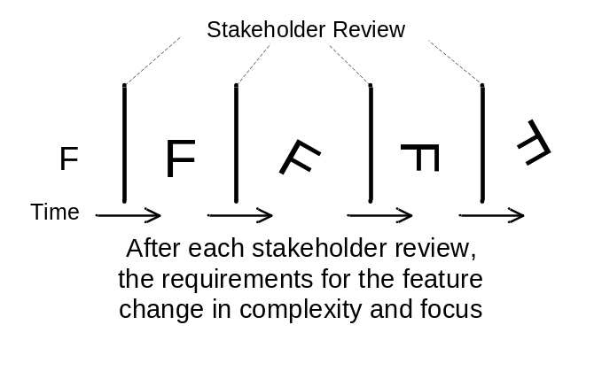

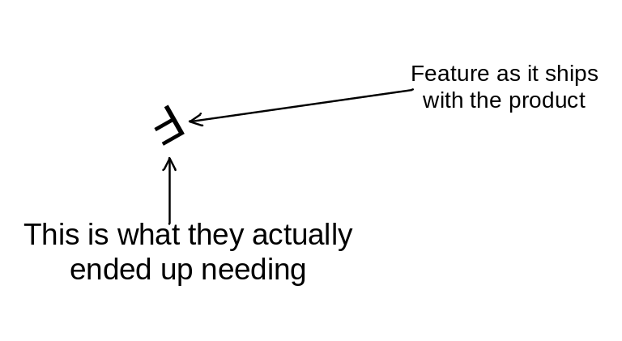

Requirements change – technology changes – markets change.

It’s all change. That is what’s normal.

So why don’t we plan and build for constant change?

Incrementally more efficient
In a marathon race, you would only have to be half a step faster than me, and then by the end of the race, you will be far over the next hill, around the curve, and completely out-of-sight.

Having started with just an incremental competitive difference – very significant difference in results .

Start out incrementally more efficient / more productive:
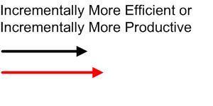

You and your competitor perform the same number of process steps, and you handily beat the competitor to the finish line:
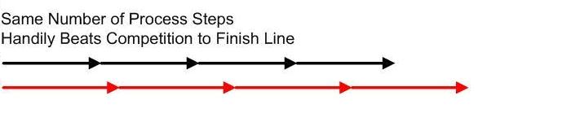

Soon it even takes fewer number of steps to surpass the competitor. So not only do you beat him to the finish line, you’ve been significantly more productive and correspondingly more profitable in doing so:
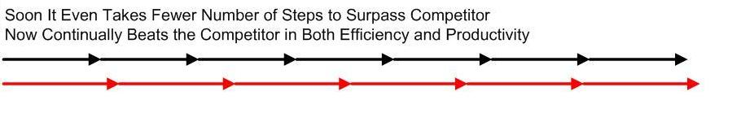

Continued improvement just accelerates this process and produces more dramatic results. Soon you own the market, and your competitor has dropped out of sight:
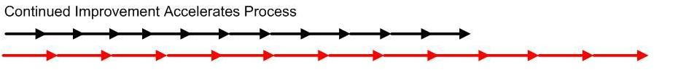

What the best developers are able to see
What the 7% “super achievers” know how to do, but which the next 25% (with all their credentials, good intentions, and effort) can’t seem to do…

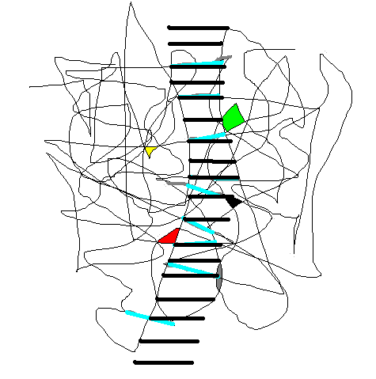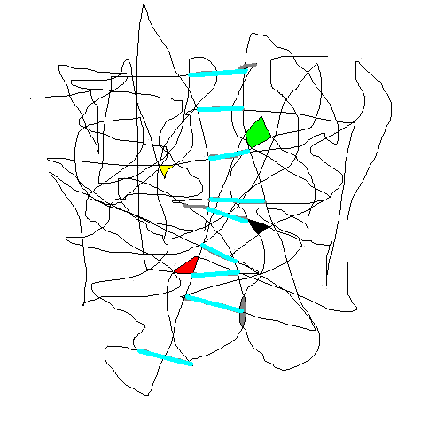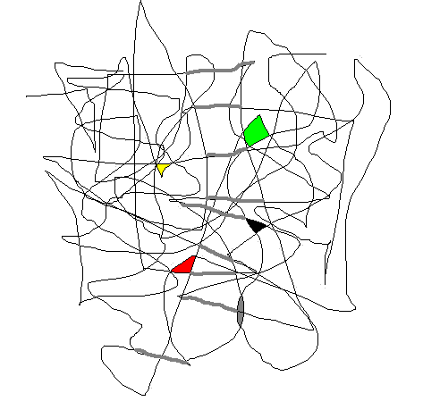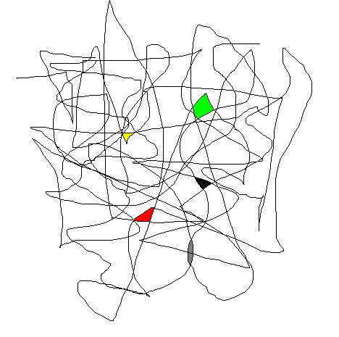
1
6
5
4
3
2
…by implication then, what the PA will assist the next 25% to successfully do…

Step 1: Every significant project very quickly presents a maze of complexity – a multi-dimensional spider web of issues, requirements, and interrelated info.

Step 2: There are items buried somewhere within all that complexity which provide the key to how to proceed in solving the problem. But how is an individual supposed to know where to look or what to seek out?

Step 3: What the best project managers and developers are able to see… They can begin to visualize steps, connections, and building blocks which present a possible path through the maze to the desired solution. (Notice the slightly gray segments which highlight those steps in the web.)

Step 4: Here the advanced developers are able to mature the concepts, pull together technologies, and develop prototypes of the components which will ultimately constitute the solution. (Note: heavier highlighting, but the steps are still a bit crooked and misshapen.)

Step 5: Developers who know how to take product to market are skilled in integrating the prototypes and components into a solid, stable system. (Note: solid black regular lines.) At this point the “next 25%” of competent developers are able to play significant roles in developing the solution application.

Step 6: A rugged, robust, very-clearly-defined system is now a product that all users are able to master and apply to their business requirements.

The apps jumble

The top 7% of developers are able make the leap from box 2 to box 4. What is missing for the others is a system (represented by box 3) which helps them make that leap from information to solutions.

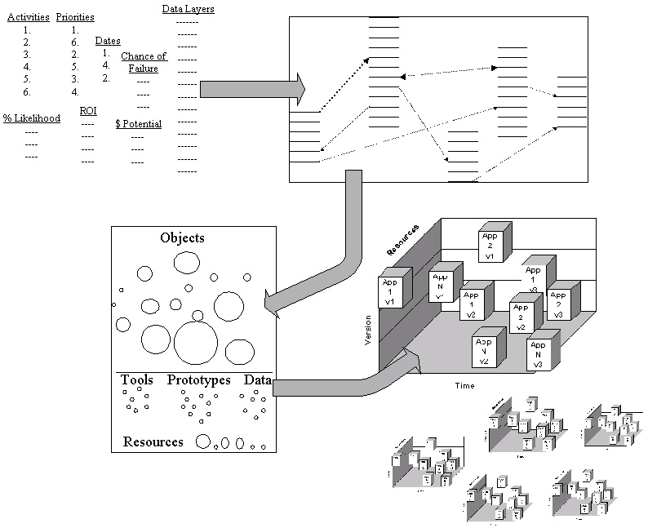
1
4
3
2

From Initial Information…
…to Visualization
…to Object Modeling
…to Multiple Products (w/ multiple versions, on multiple platforms).

Model repository using PA methods
Besides thinking of entities solely as objects or actors, the PA concept is well-suited for methods. What that means is that:

- Smart methods themselves can be stored as entities with their own attributes.

- Thus a program can ask such a complex question as:
"Find me a method that can model pipe flow from pressure, diameter, viscosity, curvature radius and pipe material.”

- The application can invoke that method, performing the calculations.

- From a programmer’s perspective:
this capability solves a universal software library problem.

- From an end-user’s perspective:
this capability allows new methods to be added into an application as they become available. They didn’t have to be pre-built into the application code.

Expansive global enterprise outlook
- Looking for a leader with an expansive global enterprise outlook.

- If we deliver business-process, productivity, and decision-assisting tools which are no more difficult to use than Excel, perhaps even as easy to use as NotePad, then...

- The whole world would use it.

- Seeking a business organization confident to distribute such a product globally.

- We are the team that can develop & deliver the product.

Thinking
- I know the business model for the big enterprise solutions – lots of seats, lots of licenses, lots of servers, lots of upgrades, charge for training, etc. Revenue flow, and a plan that bankers will like. But it doesn’t feel to me like a quick-enough-on-its-feet model – doesn’t seem like the model for defining a new market, for dominating a market, for being the best.

- Look at the simplicity of the Napster model: almost no overhead, simple in conception, simple in development, almost overnight (a matter of a couple of months) is present everywhere, all over the world. The power of networks, the power of peer-to-peer apps.
Borland model – a $50 ‘C’ compiler when everybody else’s was $659
Microsoft model – NetMeeting, Internet Explorer, etc., etc., for free
Napster model – free, easy to use, meets a demand
Google model – free, effective, and inoffensive
- Make it so useful and so inexpensive to use, that everyone will use it. Make your money with services, advertising, tools, consulting, seminars, and providing solutions.

- Conventional advice is – “Shouldn’t you define a process, sell the process, write a book about the process, lecture on the process? Then later develop software around that process and then sell it?” – No. I don’t presuppose to know your business or to tell you how to run your business. Our role is simply to help you quickly see and make sense of the complexity before you. Process information, keep track of details for you, help you picture the situation and envision a solution.

- Conventional project incentive is to bill as many hours as possible – incentive is to continually do incremental work – incentive is to always start new phases before old phases are ever done – a cash cow that just might continue indefinitely. Then what’s the incentive for becoming super efficient producing lower cost products, when sluggish, expensive, and profitable works? In my view, it is to be able to become so good that you can handle multiple such projects simultaneously, so you can handle multiple versions of the projects, and so you can have less experienced teams be able to produce these exceptional results. That’s how you dominate – that’s how you grow exponentially.

- Just over the horizon will be an unprecedented leap in computing power. Apps and the framework which can capitalize on that opportunity need to be structured 1-2 years in advance of that.

Visionary

I would wear the label “visionary” with a great deal of pride. Trouble is that a lot of visionaries throughout history seem to end up being hanged. I think this is “evolutionary” – somewhere this side of “revolutionary” and hopefully not “delusionary”. I will accept the label “delusional” if someone will just pay me to go off in a corner and pursue these delusional ideas. [G. Jay in response to C. Niedner]

How expansive a claim?
[Note: this paragraph is a repeat from the end of the S/A/F whitepaper, but if you’ve actually read this far, you probably agree with enough that you may not be upset to read it once more.]
How expansive should a claim of market potential be for such a product? With a product as easy to use as Notepad, visualization that is intuitive for everyone to see and use, business outputs and guidance for every business unit in the enterprise, tight integration with office and financial tools, models built on robust, adaptive, believable decision engines, all in the terminology homegrown in each business … there is no reason not to believe that the potential is for it to be used in every office in every business worldwide. The benefits: efficiencies in individual projects – multiple projects simultaneously – multiple phases in each project – manage orders of magnitude increases in complexity and in speed of change – garner information from intranet and internet – mine the marketplace of ideas – build – grow – adapt – thrive.

The yeah-buts
It is at this point in discussions about the productivity app that I expect to hear the “yeah-buts” come out.
- Yeah but…how can it do all that?
- Yeah but…all those technologies to try to master!
- Yeah but…it’ll be too complicated to use.
- Yeah but…how can you make money if it costs so little?
- Yeah but…it’ll be too slow.
- Yeah but…it’ll take to long to develop.
- Yeah but…
- Yeah but…
- Yeah but…
- …
- …

In 1989-1990, my colleagues in GIS (geographic information systems) software development and I talked about the possibility of creating a map repository, which people could dial up, then select the maps and satellite images that they needed, and download them for use. The “yeah-buts” came out on that one too.
- Yeah but…it’d be too slow.
- Yeah but…the files are too big to download.
- Yeah but…it’d be too complicated for users to ever master.
- Yeah but…there’s not enough disk space in the country to hold all those images.
- Yeah but…it’d overwhelm any computer system you try to use as the repository.
- Yeah but…it’d take to long to develop.
- Yeah but…it’d cost too much.
- Yeah but…
- Yeah but…
- Yeah but…
- …
- …

After ten years…what did we find? Only that every user in the country was accessing maps on the web and printing out driving instructions from point A to point B and from address C to place name D. And their rental cars were outfitted with GPS systems which displayed maps, and traced the car’s position in real-time, and had a voice which said when to make the next turn and how far to go. Can’t be done? Come on!...in ten years, it far exceeded expectations.

DON’T tell me that this productivity app can’t be developed! Yeah…sure…AND maps couldn’t be served up to the public either! Given the right team and the right leadership, this app is entirely doable. And it is needed to be able to handle the project challenges of the next 5-10 years.

I have been asked by managers at every stage of my career, on virtually every project, to “take this complex problem and program a solution…BUT keep it simple.” I turn the tables now and say, “yes, it will be complex to develop, but with unremitting focus on that word ‘simple’, the app the end-users face will appear simple and intuitive to them.”

Conclusion
I would ask you how you manage your projects. Do you have any such a system as has been described herein? What has been your experience? What results do you report?

If such software exists, then I want to use it in directing my projects. In fact, I would like to work with the people who have developed it.

If such a tool does not exist, then I want to develop it. I would love to surround myself with the kind of talent which is capable of developing this global impact application.

V. ProjSpec One-Page

A Web-Based Productivity App

Rapid Project Spec
A Web-Based Productivity App

- A Structure for Capturing, Cataloging, and Modeling Information
ProjSpec
- A Framework for Project Definition & Project Management
- Business Outputs for Schedule, Budget, & Resource Requirements

Genesis of Concept
- A remote, overseas consulting project
- Very short time to spec multi-level, multi-department, multi-application system
- Flat, 2-dimensional tools (docs, tables, spreadsheets, schedules, diagrams) prove inadequate for representing such an intricate, multi-dimensional system
- The project team capable of producing the required technical design and business report (budget/schedule/resources) must possess vast experience & advanced skills

What effective tool was needed?
- A set of applications which allows the analyst (note not programmer) to:
Encapsulate objects, Name them using the client's business terminology, Record attributes about them, Rank objects, Categorize them, Weight them, Link objects, Assign attributes to the links, and Display and Analyze the overall system of objects and links.
- Framework assists you, guides you, allows you to quickly go from imperfect knowledge to preliminary plan
- Directly output management and executive reports in standard MS Office format

Manage Project Development
- The resulting object model subsequently directs the technical development team
- Directs the effort / Captures results / Tracks progress / Produces management feedback / Notifies admin / Provides info to Sales for spec'ing enhancements and selling new projects
- Is the model for how a $5M business unit can manage the growth to $50M

True Life Observations
- A nationally known Research Institute with 800 engineers. However it is always the same pool of 15 who are good enough to conceive projects that actually work, get finished, are delivered, and can be maintained. There are thirty-five more developers, who are not quite the same world class talents, but who are capable enough to be able to implement the design set forth by those top 15. So out of 800, that's 50 real producers - 7%.
- A really big oil company buys out a smaller oil company. Oil is the asset, people are the liabilities, so the big company spins off all the employees. Up to 70 different groups explore the possibility of spawning new companies, but realistically, only 4-5 succeed - 7%.
- A university instructor consistently has this experience. Each semester with a class of 20 advanced students for computer systems applications integration, 1 or 2 "get it" without having to be led step-by-step - 7%.
- A multi-national high tech company with thousands of employees whose productivity model is to generate $400K revenues per employee for growth and profitability. What percentage of employees are the "producers" for all the rest? Is it the same 7% or can really strong recruiting, hiring practices, and training raise that percentage?
- The garage.com VC model: isn't its purpose to apply a filter to weed out pretenders, identify the 7% winning ideas?

Payout
- Beyond the 7%, at least the next 25% in each of these circumstances is populated with capable, dedicated, credentialed, hard workers. What if we can provide a framework whereby they also can succeed and approach the productivity of the elite group?
- The large company gets vast productivity and profit boost. The small company gets on a growth track. The start-up gets infrastructure, guidance, and framework. The financial community gets higher percentage success factor.
- Using the object model in programming makes the difference between professional, successful software and disorganized amateur code. Using a Web-based ProjSpec object model produces teams that can innovate faster than anyone else, can manage orders of magnitude increases in complexity and in speed of change, increase profits, and conquer and dominate market segments.

VI. Concise Presentation

These pages are from a short PowerPoint presentation.

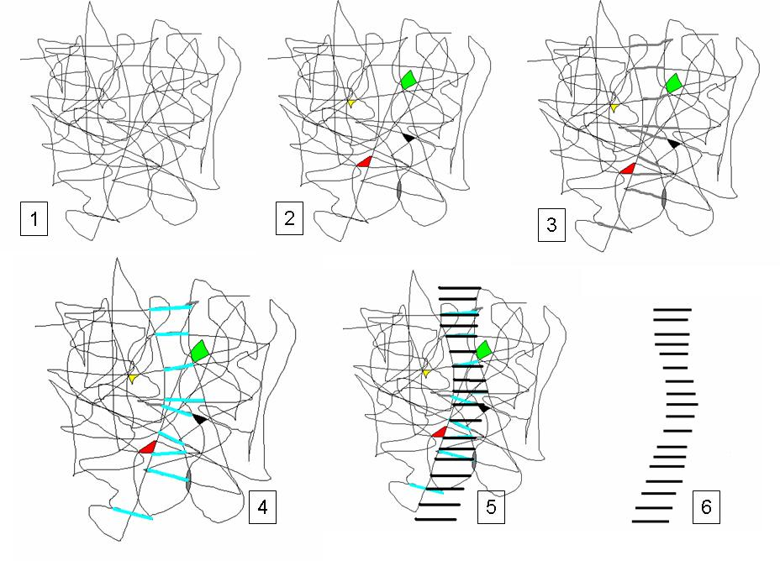

What the 7% “super achievers” know how to do, but which the next 25% (with all their credentials, good intentions, and effort) can’t seem to do…
…by implication then, what the Smart Adaptive Framework will assist the next 25% to successfully do…

Step 1: Every significant project very quickly presents a maze of complexity – a multi-dimensional spider web of issues, requirements, and interrelated info.

Step 2: There are items buried somewhere within all that complexity which provide the key to how to proceed in solving the problem. But how is an individual supposed to know where to look or what to seek out?

Step 3: What the best project managers and developers are able to see… They can begin to visualize steps, connections, and building blocks which present a possible path through the maze to the desired solution. (Notice the slightly gray segments which highlight those steps in the web.)

Step 4: Here the advanced developers are able to mature the concepts, pull together technologies, and develop prototypes of the components which will ultimately constitute the solution. (Note: heavier highlighting, but the steps are still a bit crooked and misshapen.)

Step 5: Developers who know how to take product to market are skilled in integrating the prototypes and components into a solid, stable system. (Note: solid black regular lines.) At this point the “next 25%” of competent developers are able to play significant roles in developing the solution application.

Step 6: A rugged, robust, very-clearly-defined system is now a product that all users are able to master and apply to their business requirements.

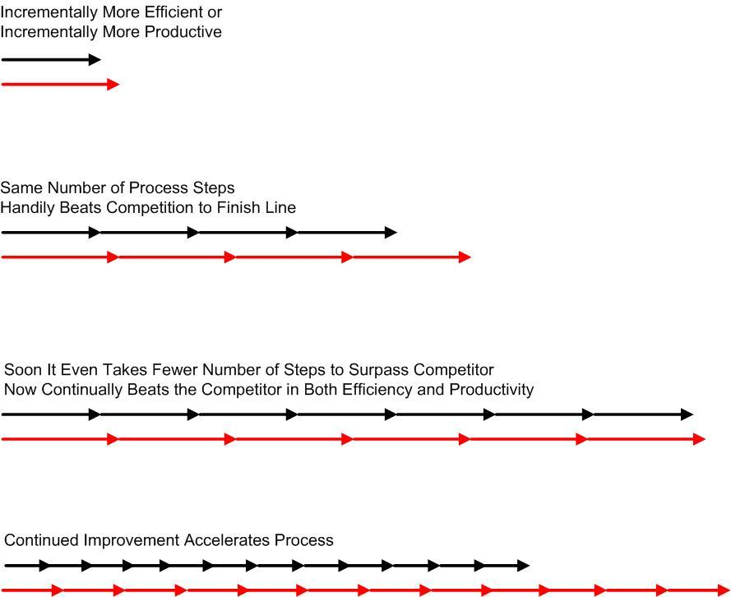
In a marathon race, you would only have to be half a step faster than me, and then by the end of the race, you will be far over the next hill, around the curve, and completely out-of-sight.

Very significant difference, very different results – having started with just incremental competitive difference.

1. Start out incrementally more efficient / more productive.

2. You and your competitor perform the same number of process steps, and you handily beat the competitor to the finish line.

3. Soon it even takes fewer number of steps to surpass the competitor. So not only do you beat him to the finish line, you’ve been significantly more productive and correspondingly more profitable in doing so.

4. Continued improvement just accelerates this process and produces more dramatic results. Soon you own the market, and your competitor has dropped out of sight.

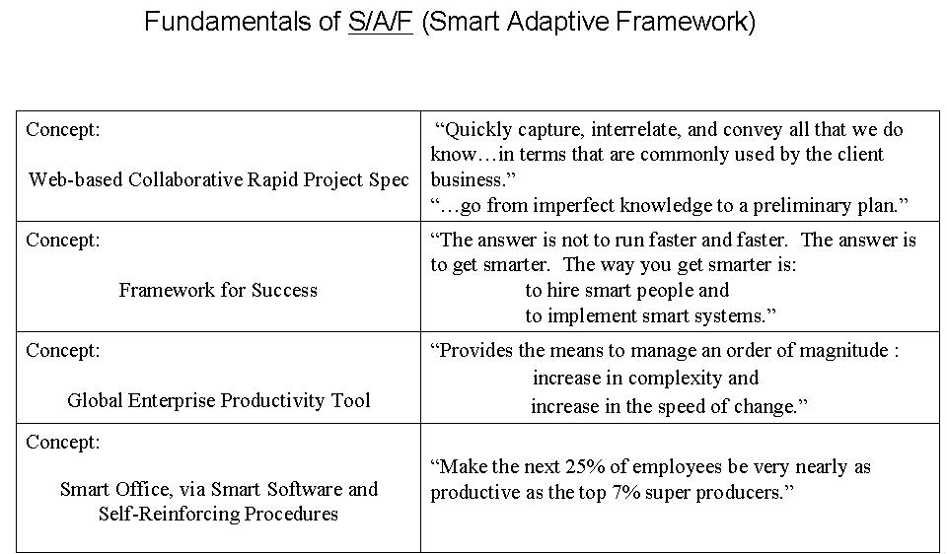

Collaborative framework.
Smart software.
Self-reinforcing procedures.

The essence of a system which can accomplish the intent of the previous two slides.

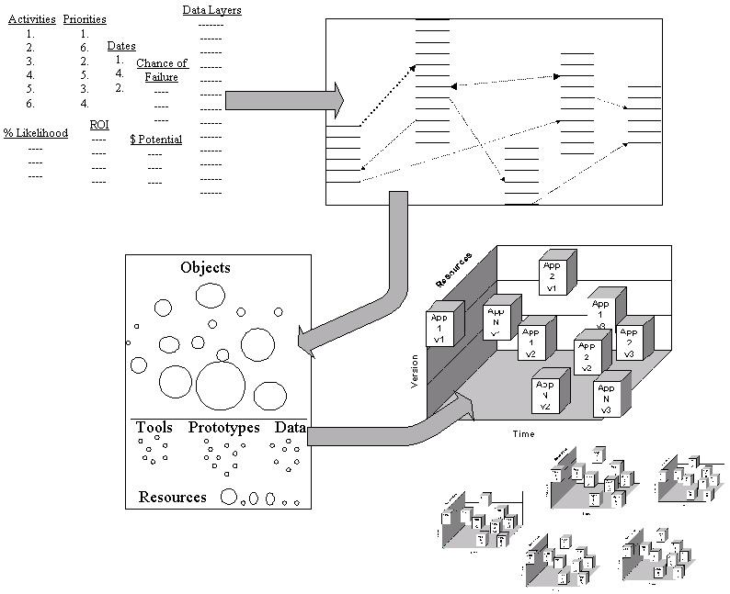
From Initial Information…
…to Visualization
…to Object Modeling
…to Multiple Products (w/ multiple versions, on multiple platforms)

The top 7% of developers are able make the leap from box 2 to box 4. What is missing for the others is a system (represented by box 3) which helps them make that leap from information to solutions.

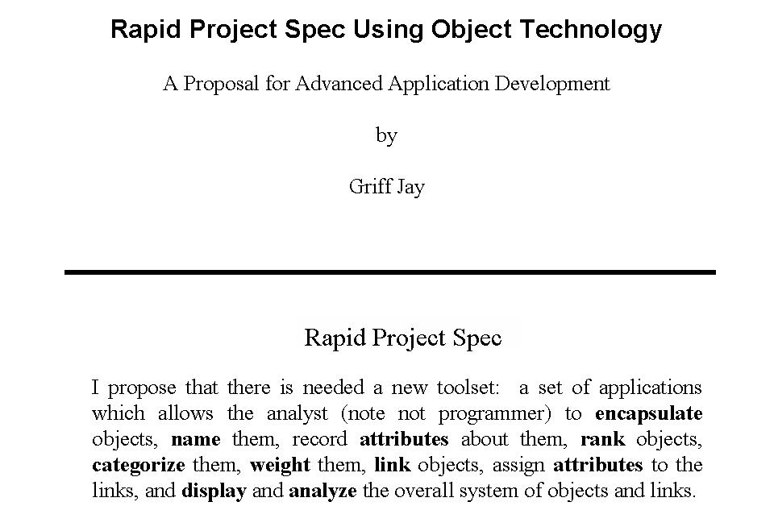

S/A/F – ProjSpec: A set of applications which allows the analyst (note not programmer) to:
--Encapsulate-- objects
--Name-- them using the client's business terminology
--Record-- attributes about them
--Rank-- objects
--Categorize-- them
--Weight-- them
--Link-- objects
--Assign-- attributes to the links
--Display-- the system of objects and links
--Analyze-- the system of objects and links

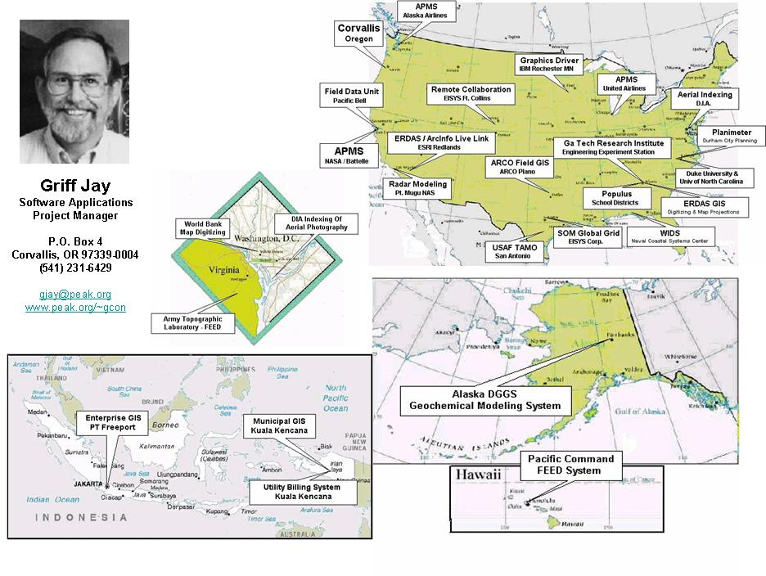

At web address: www.peak.org/~gcon there is an interactive version of this page.

There you can click on the maps and read descriptions of each of the projects.

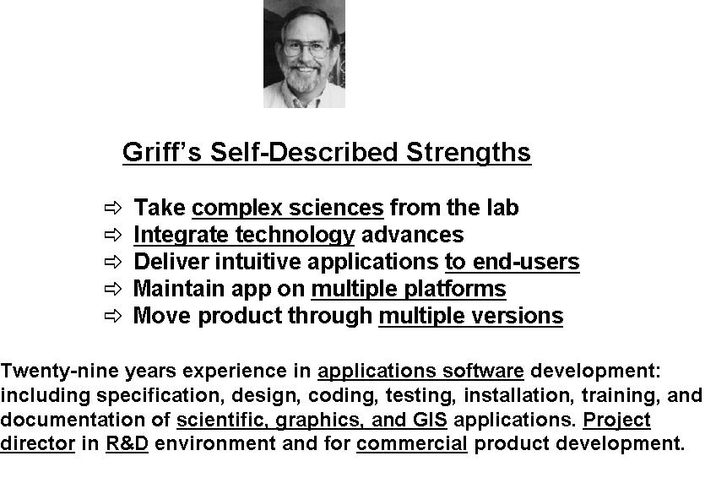

In a recent proposal process, we were challenged to succinctly describe our particular expertise, strength, or niche.

It is always easy to list proficiency in numerous languages, operating systems, and software. But this was quite a different kind of assignment, one designed to get at the essence of the roles we individually brought to the project.

